# Day:3 create a new material

## ## blueprint designing:

Emissive color -> glow(less computational)

normal -> irregularness to give realistic look

world position offset →

alt+click to delete a node

### Add texture+color to base color

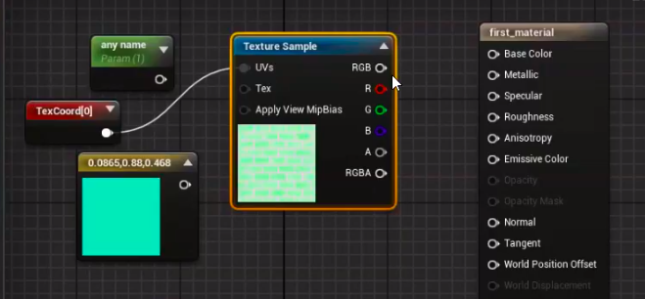

### Connect node without creating a link

> right click rgb select 'start previewing node' and hit apply

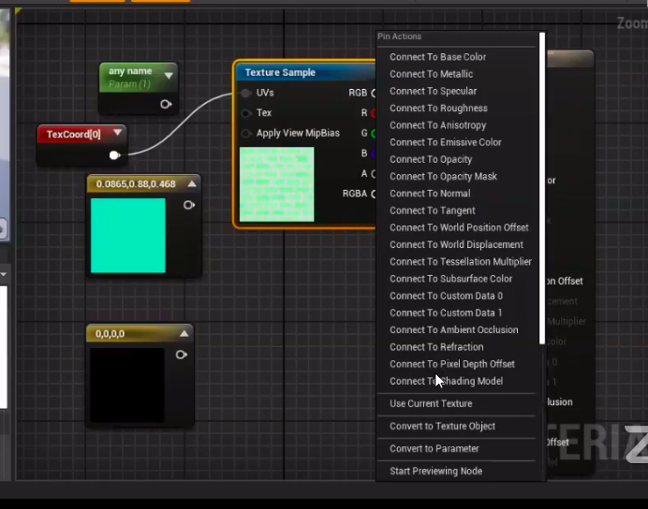

### Parent Child relation:

* create multiple child materials from parent materials
* adding parameter to parent material will also add it to child
* we can change child without effecting parent material

> right click a material and create a new copy

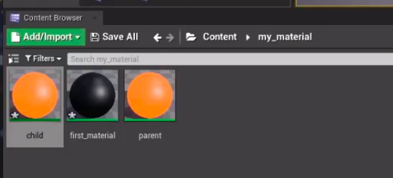

> right click node > convert it to parameter -> to change name of a node

### Changing glow of material

Creating changing glow value using time period and sine node:

select group of nodes to add label

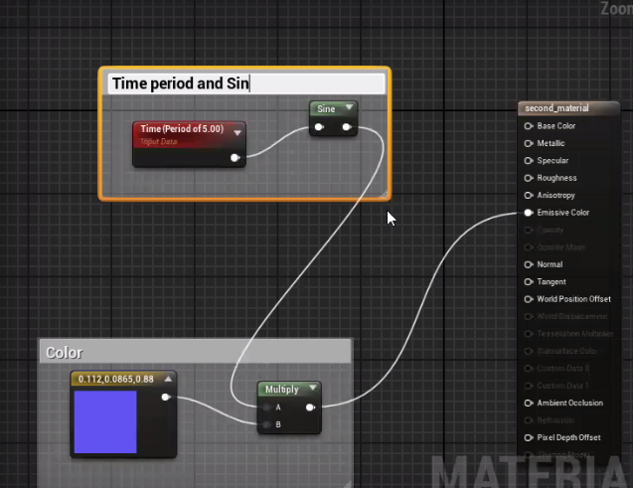

* Creating changing glow value using time period and sine node:
* select group of nodes to add label

### Assignment:

Create your own Glass material, Water material and Grass and also material with works like wind